SOEN 357 S 2244

User Interface Design

Computer Science and Software Engineering

Winter 2025

Case Study:

UX/UI Design of a Health Companion Super App

‘RemindMeds’

Webpage: <https://medium.com/@miskatmahmud0/remindmeds-your-health-companion-super-app-c7f68b576727>

By: Miskat Mahmud

Student Id: 40250110

Instructor: Dr. Hakim Mellah

Due Date: 23 February 2025

Contents

Introduction 3

Understanding the problem 3

User Research 4

Online Survey 4

User Personas 9

User Journey Map 11

User Flow Diagram 12

Storyboard 13

Sketches 14

Wireframes 15

Final Design 17

Iterations 17

Color Palette 18

Typography 19

Prototype 20

Plan for Usability Testing 25

Reflection & Conclusion 26

Reflecting upon user feedback and influencing feature choices 26

Reflecting upon user feedback and influencing design choices 27

Challenges 27

Prototype 27

References: 28

# Introduction

It can be difficult to keep track of prescription drugs and doctor's appointments. Even more difficult for those with chronic medical issues, busy professionals, and caregivers who are responsible for a loved one's health. Many people have trouble scheduling doctor's appointments, remembering to take their medications on schedule, and monitoring their general health. This case study explores the user experience (UX) design of a health companion super app - ‘RemindMeds’, an app that is developed to track medication dosage, appointment scheduling, and caregiver connection.

In order to make sure that ‘RemindMeds’ is user-friendly and accessible for all users, this study employs a user-centered design methodology that includes user research, journey mapping, sketch, wireframing, prototyping, and usability testing. The app was designed based on the needs of different personas such as an elderly patient, busy professional or a caregiver. The mission is to create a simple app that makes the daily life easier for people facing such problems.

# Understanding the problem

For many people, especially those who are managing chronic diseases, medication adherence is a major difficulty. According to a recent Express Scripts® Pharmacy-sponsored research [1], 59% of patients on maintenance drugs had missed a dose. Furthermore, according to the U.S. Centres for Disease Control and Prevention (CDC), pharmaceutical non-adherence causes 125,000 deaths annually and accounts for 30% to 50% of treatment failures for chronic diseases (Employee Retirement System of Texas, 2023). These figures demonstrate how urgently digital solutions that assist users in remembering their appointments and prescription schedules are needed.

In addition to medicine reminders, many patients have trouble remembering their doctor's appointments, which results in missed visits and postponed treatments. It can also be challenging to get in touch with healthcare providers in a timely manner, particularly when a doctor, pharmacy, or clinic needs to be contacted. Caregivers frequently lack the resources necessary to effectively monitor their loved one's medicine intake and general health state for those who need assistance.

By offering timely reminders about medications & appointments, caregiver support, and easy access to healthcare providers, ‘RemindMeds’ aims to address this problem and ensures that patients remain consistent with their health needs.

# User Research

### Online Survey

I have conducted an online survey [2] in order to better understand user needs and challenges in managing medications and doctor appointments. The survey gathered insights on medication adherence, appointment tracking, doctor communication, and additional feature preferences for the ‘RemindMeds’ app [3]. The results were divided into four key sections:

**Age and Health Condition**

The survey included respondents from various age groups, with the majority falling within the 18-24 age range. A significant portion reported not having a chronic health condition, while those who did required regular medication and medical visits. This highlights the need for a flexible app that serves both chronic patients and those with occasional healthcare needs.

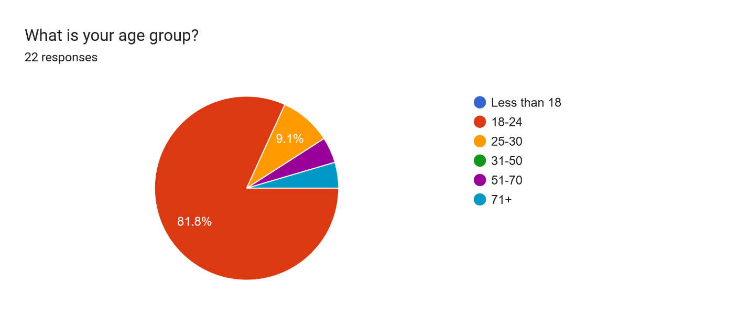

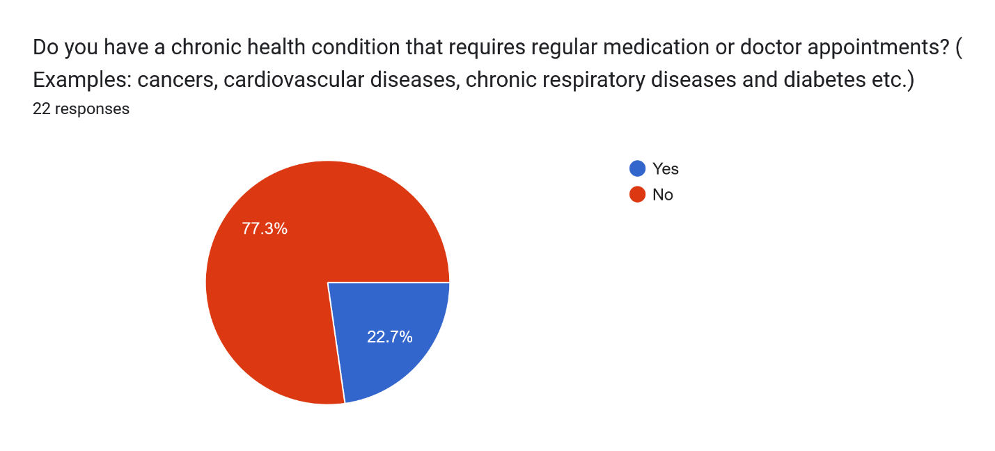

**Medication Management**

When asked how they track their medication, most users rely on phone alarms and reminders. Some write down their schedules manually, while a few do not track their medications at all. Over 50% admitted to missing doses at least sometimes, reinforcing the need for stronger reminder systems within the app. Only 1 person responded that they use a dedicated app for their scheduling. This means that there is a lack of public knowledge about existence of such app.

Forms response chart. Question title: How do you currently keep track of your medication schedule? (Select all that apply)
. Number of responses: 22 responses.

Forms response chart. Question title: Have you ever forgotten to take your medication or missed a dose?
. Number of responses: 22 responses.

**Doctor Appointments & Communication**

The most common appointment tracking methods were calendar apps and hospital reminders. Some users still forget appointments, showing a need for appointment reminders with rescheduling options. Phone calls were the most preferred method of contacting doctors, but many respondents showed interest in a direct in-app messaging feature for better communication.

Forms response chart. Question title: How do you currently keep track of doctor appointments? (Select all that apply)
. Number of responses: 22 responses.

Forms response chart. Question title: How do you usually contact your doctor if you have medication-related concerns?
. Number of responses: 22 responses.

Over 80% of the respondents revealed that having an app for these sorts of reminders would be very helpful for them. They have also shown an interest in having direct chat/contact option with their healthcare providers. This shows that they prefer ease of communication.

Forms response chart. Question title: How helpful would it be to have an app that reminds you of both medications & doctor appointments?
. Number of responses: 22 responses.

Forms response chart. Question title: Would you like an app feature that allows direct messaging with healthcare professionals?
. Number of responses: 22 responses.

**Difficulties & Additional Features**

The mostcommon challenge was that they keep forgetting to take their medications. This can happen if you are an elderly person and someone with a busy life schedule. Hence, having a reminder for medication was the most important feature of this app. Other challenges were missing appointment times, and difficulty in organizing health information.

The most requested features were:

* Simple medication reminders
* Appointment scheduling & tracking
* Direct messaging with doctors
* Easy prescription refill requests

Forms response chart. Question title: What feature would you like most in a health management app? (Select one)
. Number of responses: 22 responses.

The results confirm that RemindMeds must prioritize ease of use, smart reminders, and efficient providers-patient communication. The inclusion of a caregiver connection feature will also benefit those who need assistance in managing their health. In addition to these features, I have also added additional features such as voice assistance, chatbot, general information, emergency call etc. The aim is to have an app that would meet most of your health needs in one place.

# User Personas

Based on the survey, I created three potential users for this app. Their personas represent the needs of a typical user, their expectations and goals. It also highlights the area where the feel challenged and the frustrations that come with it.

1. Katherine (The Elderly Patient) – A 65-year-old retired teacher who struggles with remembering her medications and doctor appointments. She needs simple reminders and an easy-to-use interface to stay on track with her health.

1. Walter (The Busy Professional) – A 38-year-old software engineer with a demanding schedule. He often forgets his medications and appointments due to his workload and needs automated scheduling and seamless calendar integration.

1. Mary (The Caregiver) – A 25-year-old full-time caregiver managing her father’s medications and appointments. She requires real-time tracking and caregiver alerts to ensure her loved one stays on top of their health.

# User Journey Map

From finding the app to reaching their health objectives, the User Journey Map shows how various users engage with RemindMeds step-by-step. We can pinpoint important touchpoints, feelings, and difficulties at every level by examining Ketherine, Walter, and Mary's experiences. I was aiming to improve the user experience (UX) by making sure the software is user-friendly, accessible, and successfully meets the needs of both patients and caregivers.

# User Flow Diagram

The user flow diagram provides a clear visual representation of how users will navigate through the ‘RemindMeds’ app, ensuring an intuitive and seamless experience. It maps out key interactions, such as setting medication reminders, scheduling doctor appointments, tracking adherence statistics, and communicating with healthcare providers or caregivers.

# Storyboard

Based on the survey, personas and user journey, here is a storyboard. This reveals how a user can use the features of this application. It shows how a person can feel confident with his medical needs with the help of this app.

# Sketches

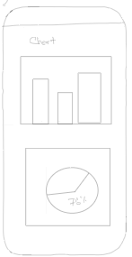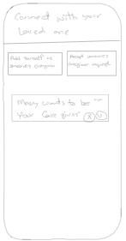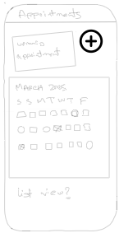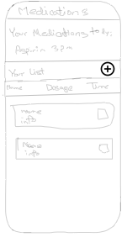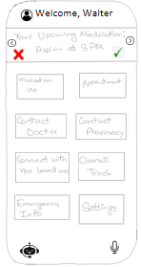The initial app design can be seen through these sketches. Some of these designs made it to final design, while some were also refactored during other steps of the design phase.

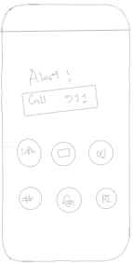

# Wireframes

Here are the wireframes I generated based on the sketches made earlier. It is laid out in a grayscale prototype. The wireframes are developed based on personas’ needs, journey map and user flow journey. It focuses on ease of usability and meeting the expectation of users. These wireframes will later be used to design the final prototype.

0

# Final Design

Here is the final design of the app step by steps. I will present and justify my choice of colors and font. I am presenting the different iterations that made me finally choose the combination of color and fonts. And finally, the prototype of the app is presented. You can also see the animations once you preview the app in the prototype section.

## Iterations

I tried out different combinations of color and font. During each iteration, I was able to see what can be done or improved on the next iteration. Here is an example of medication list page.

## Color Palette

I want to ensure that I have a common color theme all over the application. I also wanted the colors to be soft yet distinct. The colors are distinct enough so that user can easily recognize which color goes with which feature. But not too different that it creates a discrepancy.

Since ‘RemindMeds’ is a health-focused app, I wanted to avoid overly bright colors that could cause eye strain.

* Main Background (#D9D9D9) — A soft gray that keeps the interface neutral and easy on the eyes.
* Medications (#C1C7D2) — A muted blue gray.
* Appointments (#B0B0B0) — A neutral gray.
* Doctor Contact (#C8C3D2) — A subtle lavender tone.
* Pharmacy (#C8DCD1) — A soft green gray.
* Connecting with Others (#C9C4B6) — A warm beige gray.
* Font Colors (#000000 & #FFFFFF) — Black and white ensure high contrast and readability for all users.

Which is why I chose a calm, neutral ‘grayish’ color palette to create a soothing and accessible experience for users of all ages.

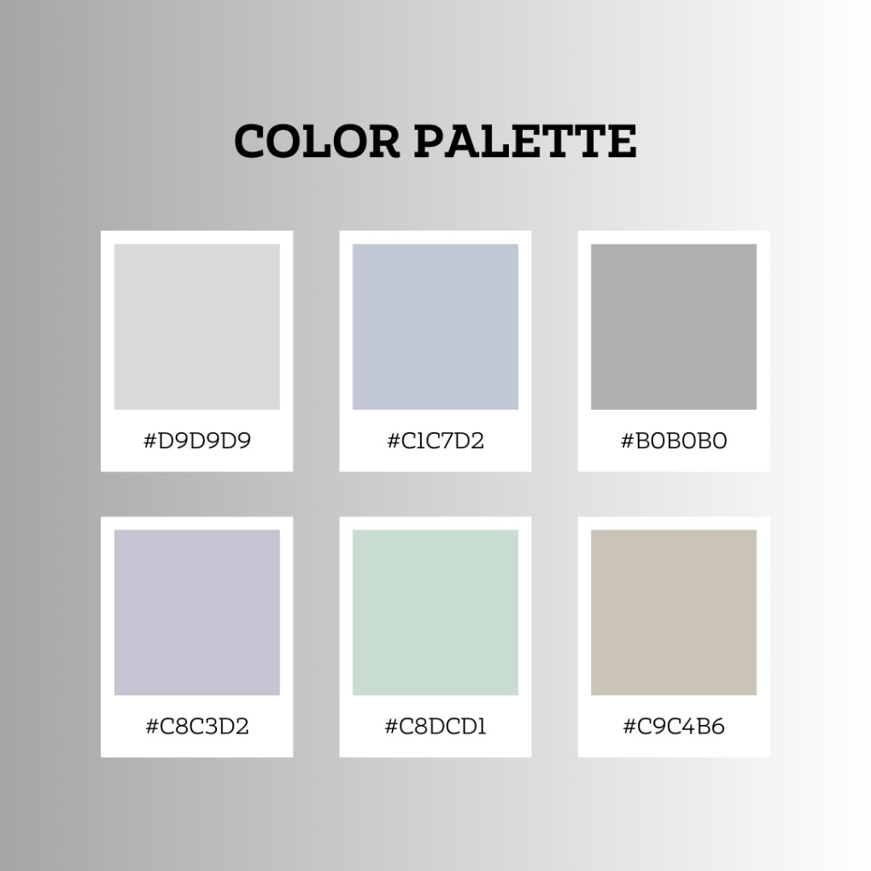

## Typography

For ‘RemindMeds’ , I have chosen REM as the font style. The current sans-serif design of the REM font family has distinctive out-strokes and low contrast. Which gave the app a sleek, modern appearance.

I have chosen REM because its elegant design improves readability and guarantees that users, particularly senior citizens and caregivers, can easily navigate the interface.

Additionally, REM (Rapid Eye Movement), symbolically relates to the app’s goal of keeping users vigilant and on track with their health.

I aimed to keeps a sleek and contemporary look by integrating REM, which enhances the app’s visual appeal and usefulness.

## Prototype

[Click to preview the prototype](https://www.figma.com/proto/2F7sA0hvhvQhR5LEGE4ptu/Main-Page?node-id=1039272-902&t=nN67HUEkmraSj8jI-1&scaling=min-zoom&content-scaling=fixed&page-id=1039272%3A575&starting-point-node-id=1039272%3A902)

The starting page has the logo and sign in/sign up option like any typical application. Once the user logs in, they will be able to see their upcoming medications and appointments on the ‘overview’ page. I wanted to make it bigger and clear with enough information on each of the tile. There is also ‘next’ and ‘previous’ button which allows user to easily go through their upcoming events. The app will send the user a reminder to take their medication or attend their appointment in timely interval. Additionally, I have added a green check mark and red cross icon, which user can click to let the app know that they have taken their medication or went to their appointment. This can give the user a sense of achievement as they finish through their task. The user can click on Main menu to check out the other features the app has to offer. In the main menu, I have focused on making a big tile for each of the features with clear color distinction.

From the main menu page, user can choose to go to medication to see their upcoming medication, view their list of medication (with additional info) and add any if necessary. The same interface is also available for the appointments, just with a different color. The user can also toggle to calendar (icon at the bottom) view to see their appointments. I have also added easy integration with google calendar or Microsoft outlook calendar. The lists are clearly separated and pops out of the screen for better visibility.

Next feature I added was contacting the doctor or health care providers easily from the app. I have added distinctive icon to easily call or chat with the doctor or book an appointment. The user can also contact their pharmacy and ask for a refill with a simple click of the button. To be able to connect with a caregiver, such as (Mary persona being a care giver for her father) I have added a connect page. Here, the user can accept/decline a caregiver request. They can find someone as their caregiver and easily contact them with a click of an icon. Again, the features are clearly distinguished by color for better usability and familiarity.

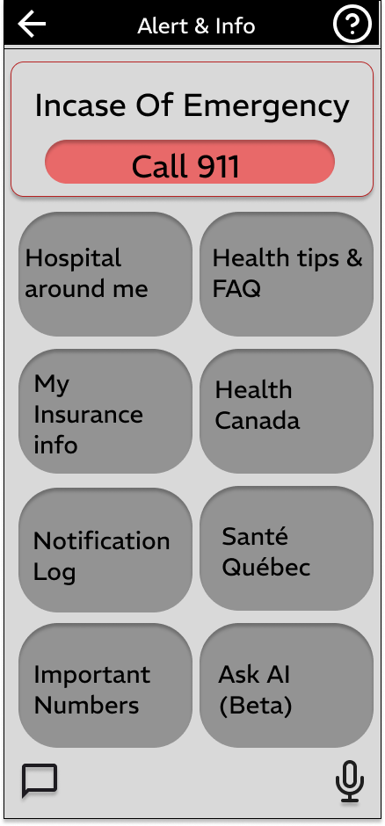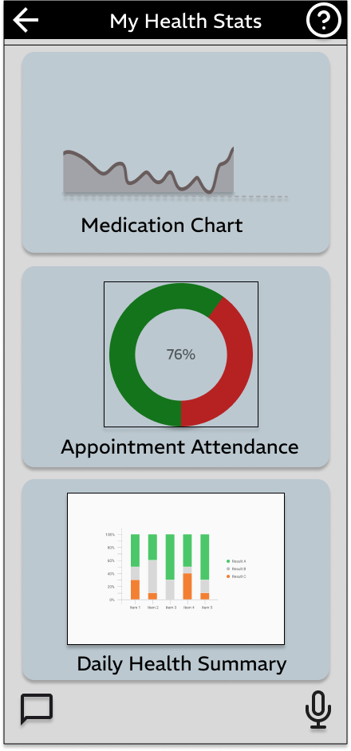I have added a statistics page to let the user know about their performance. This can be how often they miss/take their medication, their appointment attendance rate. These stats can be shared with the caregiver such that they can also keep track of their loved one’s health. I have also added an ‘Alert & Info’ page. This is to make the app even more versatile. In addition to reminders, I wanted the app to serve with general information. It can call to emergency service or take you directly to some of the health-related sites. The settings page can offer the modification of the app as the user sees fit. The list and tiles of these pages are clearly designed to help user find their required information.

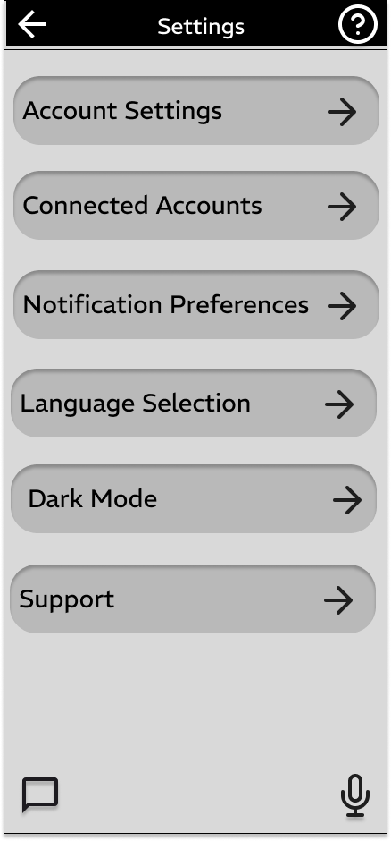

Finally, the reminder notification can be sent to user’s phone at regular interval. The user will get notification as the time for medication and appointment approaches. I have added enough information in the notification to let the user know about their upcoming events without even opening the app. Keeping the user’s needs in mind I have also added button to help the better serve their needs.

## Plan for Usability Testing

I can plan a usability testing to verify the usability and functionality of the app. The goal is to evaluate the ‘RemindMeds’ ability to meet the users’ needs & expectations. Most importantly, does it solve the problems mentioned earlier? Such as user keeping track of their medications and appointments with the help of the app. Or the user has easy contacting option with their doctors or pharmacy. Can the caregivers keep track of their loved one’s health? Additionally, can the app serve as an important hub for their health needs? To be able answer these questions, this is how I can plan a usability testing and use the feedback to improve in future iterations.

# Reflection & Conclusion

Now that the app design is over, I can reflect upon the design process I had to meet the users’ needs. My goal was to resolve the persona’s frustrations, address their pain points based on the user journey map and finally meet their expectations.

## Reflecting upon user feedback and influencing feature choices

Here are some of the feature choices I made based on user demand. This UX design process helped me with identifying user needs.

* Elderly person like ‘Katherine’ can lose their way in a complex app. I have attempted to make the app as simple and straight forward as possible.
* Added a clear notification reminder on the pages with enough information, so that users can keep track of their needs easily.
* For tech savvy users like ‘Walter’, I have added easy third-party calendar integration such that they can merge their medication time and appointment dates with the rest of their schedule.
* Having direct call or chat button to doctors and pharmacies. I have also added button, so that user can book an appointment or ask for refill with a simple click of a button.
* For users like ‘Mary’ and her father, I have added caregiver option to easily connect them. Now, Mary can keep track of her father’s health without calling him every time.
* A statistics page for the users to see how they are doing and how they can improve.
* An additional feature that can serve as an information hub for other health related issues

## Reflecting upon user feedback and influencing design choices

These are some design choices I made to make the app as user friendly as possible.

* Having big and distinguished colored tiles (in main menu page) to let the user easily navigate to their desired functionality.
* Adding different views (list and calendar) for appointment and easy switching between them.
* Having big and easy to read buttons.
* Having a soothing color and following an overall theme through out the app. Avoiding any use of bright colors.
* Adding check mark to give the user a sense of achievement. (in medication and appointment page).
* Adding help button and displaying it on every page, such that user can get help with the app’s functionality and navigability.
* Adding a mic button for voice assistance. Such as user can say, “Set a reminder for doctor’s appointment next week.”
* Adding a chat button to quickly check for any info with the help of an AI

## Challenges

The biggest challenge I faced was meeting the users’ needs and expectations while keeping the app as simple as possible. From the beginning, my goal was to keep the app simple and straightforward. I did not want bombard the user with lots of texts and overflow of information. I was able to overcome this issue by introducing icons and relying on them for some of the tasks. For example: instead of having a button that said: ‘Ask for a refill”, I added an icon that represent a ‘prescription refill’ message. The user can simply click on that and get their necessary refill without even contacting the pharmacy. Same approach was followed for booking an appointment with a doctor.

## **Prototype**

Prototype link: <https://www.figma.com/proto/2F7sA0hvhvQhR5LEGE4ptu/Main-Page?node-id=1039272-902&t=nN67HUEkmraSj8jI-1&scaling=min-zoom&content-scaling=fixed&page-id=1039272%3A575&starting-point-node-id=1039272%3A902>

# References:

[1] <https://www.ers.texas.gov/news/did-you-forget-to-take-your-medication>

[2] <https://forms.gle/owDw92nFoVv5MJMaA>

[3] <https://docs.google.com/spreadsheets/d/12QOQdesj-lICNV-eKI6dYyC04wGulLX_vw7oM6oBpeI/edit?usp=sharing>